2400032662 M.Praveen Reddy
GITHUB: Full-Stack-Lab/src at main · PraveenReddy-06/Full-Stack-Lab

#SKILL - 10 ➔ React State Management using useState Object
Prerequisites:
- Basic Idea of JavaScript
- Knowledge of React fundamentals

An online academic portal wants to maintain a list of students where the user can add new students, display the list, and delete a student instantly without refreshing the page. The application should use React Hooks to manage data at the component level so that the UI updates automatically whenever the state changes.

Your task is to implement a React component using useState to store an object array, add new items, display them, and delete them dynamically.

- Create a new React component named StudentManager.
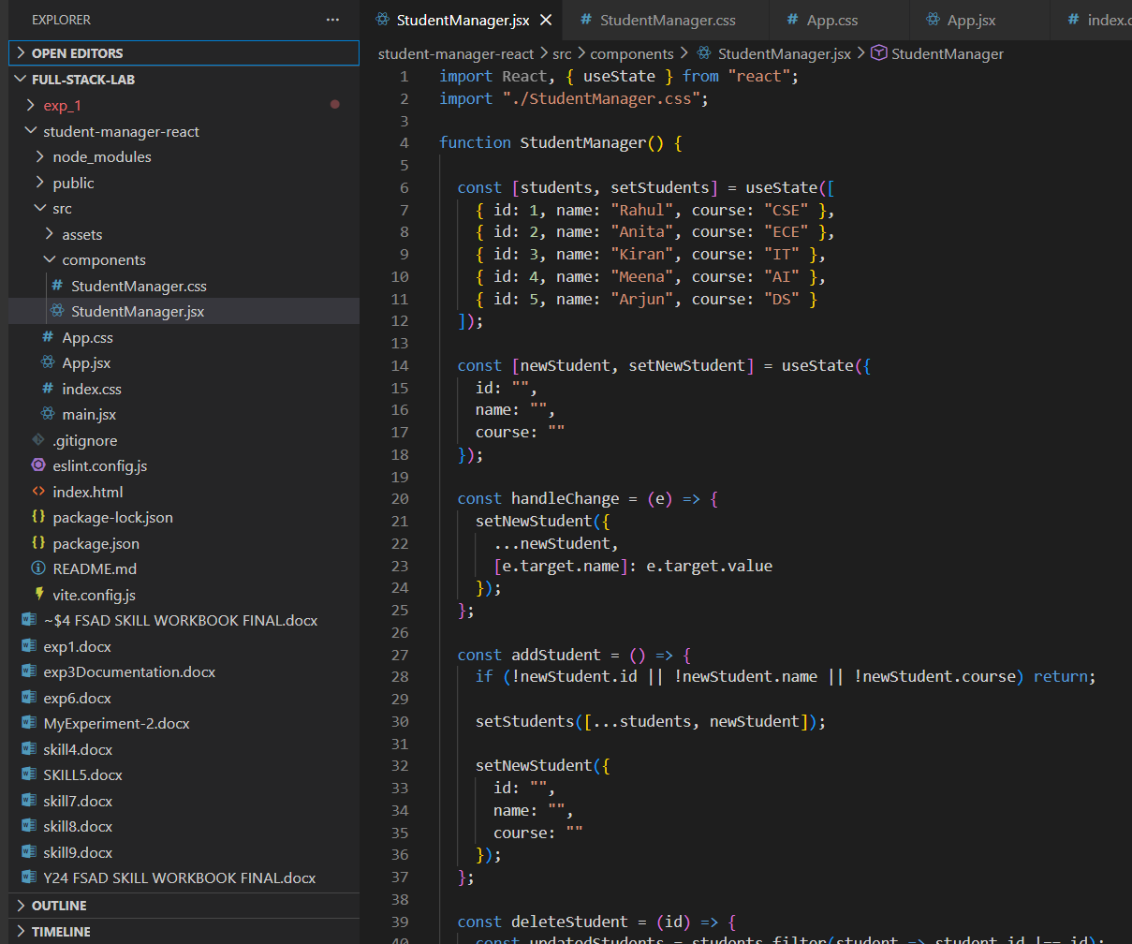
- Inside the component, create an initial students array with at least 5 objects containing: a. id
  - name
  - course
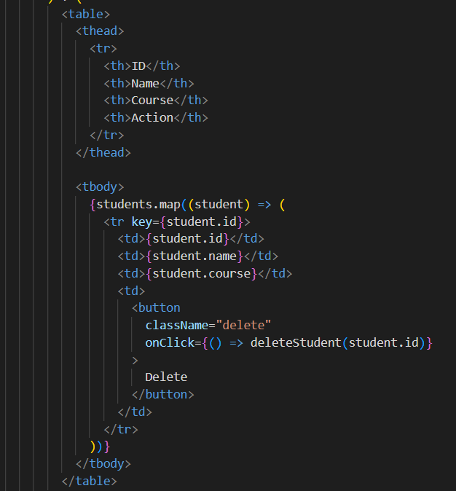
- Use useState to store:
  - students (array of student objects)
  - newStudent (object with fields like id, name, course)
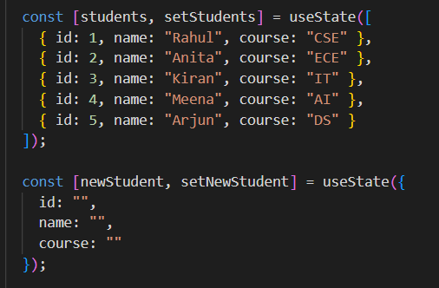

Create input boxes to accept id, name, and course.
i.Update the newStudent object using onChange events.

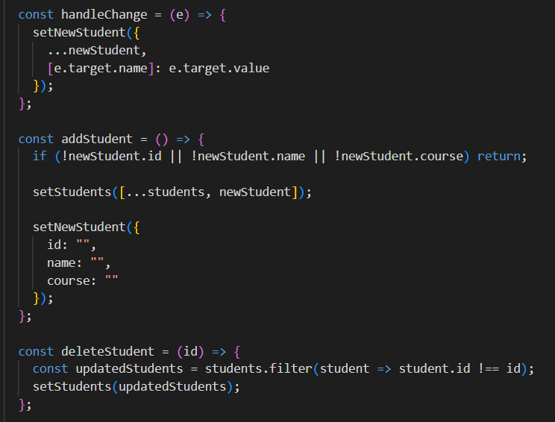
Create an Add Student button.
    - On click, add the newStudent object to the students array.
    - After adding, clear the input fields.
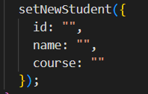
Display the list of students below using the students state.
Each student row should have a Delete button.
    - On clicking delete, remove the record from the students array.
    - The UI should update immediately using setStudents.
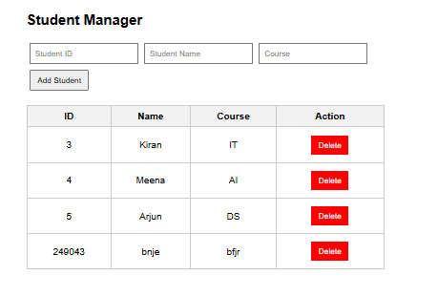
If the list becomes empty, display the message:
"No students available"
Add basic CSS styling for a clean UI (margin, padding, table style, buttons).
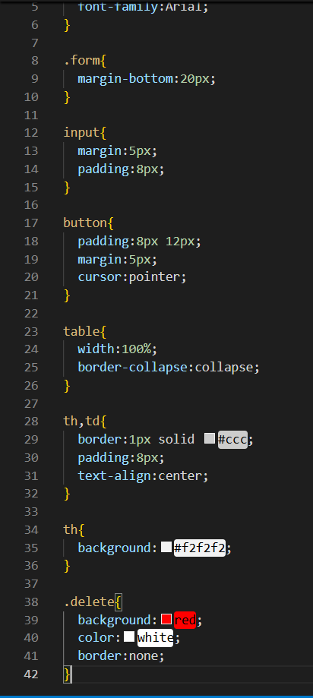

Push the React project to GitHub.
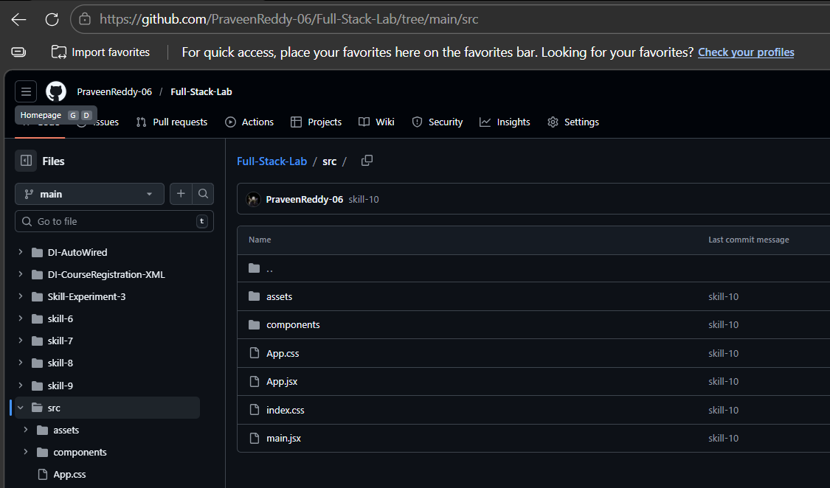

VIVA QUESTIONS:

1. What is the purpose of the useState hook in React?
useState is used to create and manage state variables in functional components. It allows React components to store and update data dynamically.

2. How does React update the UI when state changes?
When setState (or setStudents) is called, React re-renders the component and updates the UI automatically based on the new state.

3. Why do we store form inputs in state for controlled components?
Storing inputs in state allows React to control the form elements. This makes validation, dynamic updates, and form handling easier.

4. What is the importance of using keys when rendering lists?
Keys help React identify which elements changed, were added, or removed. This improves performance and prevents UI rendering errors.

5. Can one component use multiple useState variables? Why?
Yes. A component can use multiple useState variables to manage different pieces of state independently (e.g., students, newStudent, search, etc.).

